# FPT ACADEMY INTERNATIONAL

# FPT – APTECH COMPUTER EDUCATION

# *******

**PC-CENTRE WEBSITE**

|  |  |  |
| --- | --- | --- |
| **Supervisor:** | Dang Kim Thi | |
| **Semester:** | 1 | |
| **Class:** | T1710M | |
| **Group:** | Kimochi | |
| **Member:** | Full name | ID number |
| **1.** | Hoàng Văn Bình | HVD00682 |
| **2.** | Mai Văn Tuế | NTD00678 |
| **3.** | Nguyễn Trọng Hùng | DXD00674 |
| **4.** | Vũ Thị Thu Hương | VTTD00655 |
| **5.** | Đỗ Xuân Tiến | MVD00660 |

**Hanoi, May 13th 2018**

**Table of contents**

1. *Definition of problems*
2. *Customer requirements specifications*
3. *Design of the website*
4. *Sitemap*
5. *Mock of the website* 
   1. *Home page*
   2. *Pay page*
   3. *Help page*
   4. *Privacy page*
   5. *Term page*
   6. *Contact us*
6. *Website description* 
   1. *Home*
   2. *Pay*
   3. *Help*
   4. *Privacy*
   5. *Term*
   6. *Contact us*
7. *Introduction and website installation*
8. *Summary*

# Definition of problems:

* In today's modern society, buying and owning technological items quickly and conveniently is essential. For those who do not have a lot of time to go to the shop and choose from a variety of products is not possible. So creating an ecommerce site will make it easier for people to see what they want to buy without having to go directly to the shop.
* PC-shop center is a shop selling technological products include: laptop, USB, earphones, keyboard, hard drive, etc. Due to rapid development in internet field, the company decides to launch a website where people will get all the information about the various products available with them easily.
* The website is to be developed for the Windows Platform using HTML5, CSS and JavaScript.

1. **Customer requirements specifications**

* Home page should display the news and offers by various dealers
* The home page should have a link to products page. This link should display the available products sorted category wise. There will be a number of categories here, so needs to be very careful while forming the categories and designing, it should be very much user friendly. The products can be broadly categorized into:
  + Displays
  + Motherboards & processors
  + Notebooks
  + Storage
  + Memory
  + Modems
  + Sound
  + Mice / Keyboards
  + Etc
* The categories above can further lead to sub-categories.
* When user clicks on any of the product category, it will either display a list of products in that category or link to sub-category which in turn will show the products.
* The click on any of the product will lead to a page containing thumbnail images of the products, features and price details.
* Help & FAQs: this page will give the information about locating the technical support centres and most commonly asked queries and answers for these queries. The site should also provide a catalogue of the standard company products like dell, acer, Toshiba etc. This catalogue will contain products only of that particular company, price details and dealers locations.

1. **Design of the website**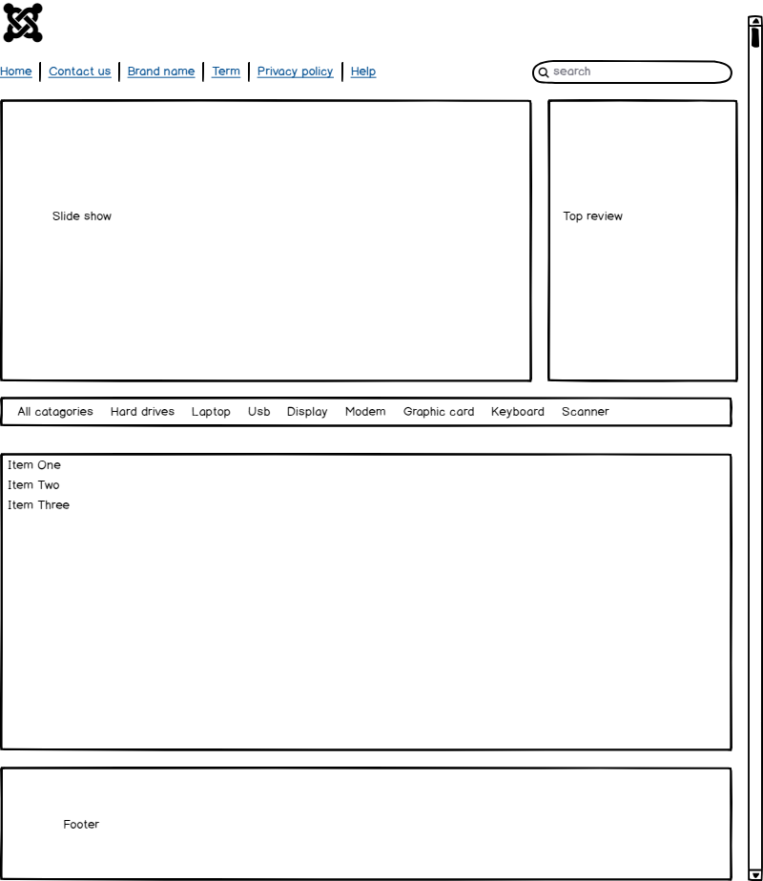
2. **Sitemap**

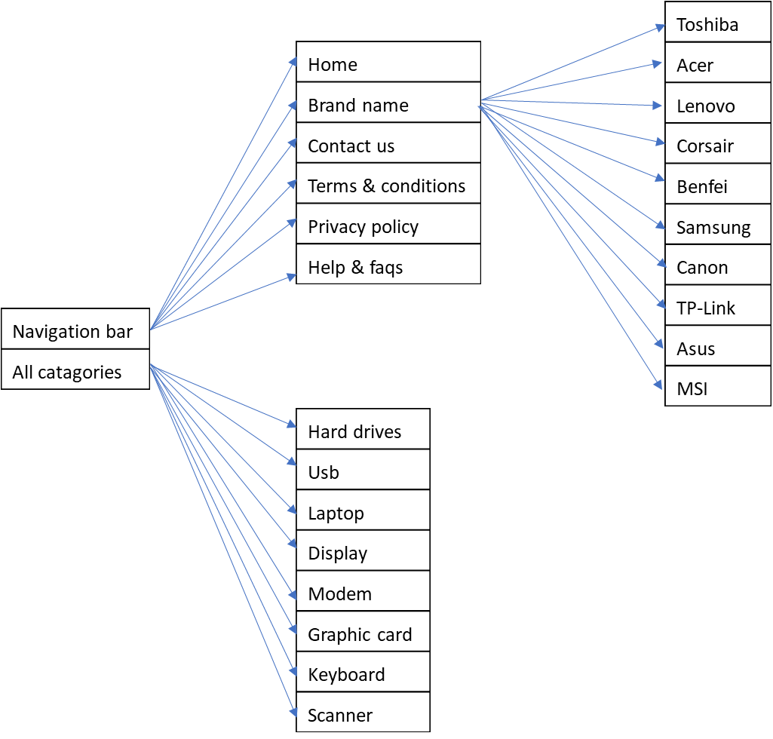

1. **Mock of the website**
2. Home page:
3. Pay page:



1. Help page



1. Privacy page





1. Term



1. Contact us





1. **Website description**
   1. Home

* This webpage section displays following informations: PC-Centre logo, navigation bar, slide show, top review, all products and contact us.
* Screenshot:

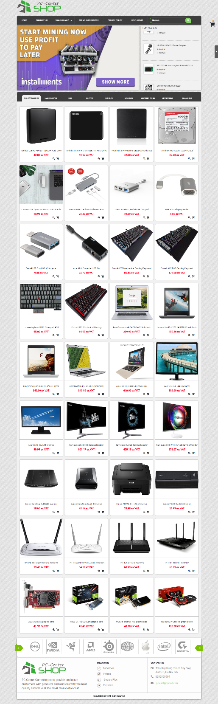

* The menu bar allows users to navigate to every webpage section of the whole website. For example, user need to visit privacy policy by clicking to privacy policy so it will go to the privacy policy page.
* In the body of home page, user can find any product by using categories.
  1. Cart
* The cart contains information about the product you want to buy including: image, product name, quantity, price, and finally the total amount for all the products you want to buy.
* Screen shot:

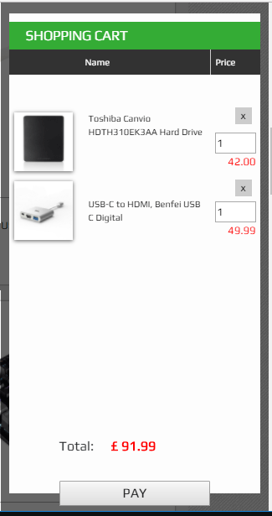

* 1. Pay
* This page displays detailed checkout steps about: customer’s account, shipping methods, payment methods.
* Account: You can choose 3 methods as: Login if you had account, register new account if you didn’t have account or check out as guest.
* Shipping: After you choose the payment method, you continue to the next step choose the shipping method. You must fill out the form containing: Name, Last Name, Street Address, City, Country. Then you choose three modes of transportation: Home Delivery, Immediate, Courier Shipping.
* Payment: Finally, You choose one out of 3 payment methods: **Card Payment Secured, Installments, Paypal Secure Payment.**
* Screenshot

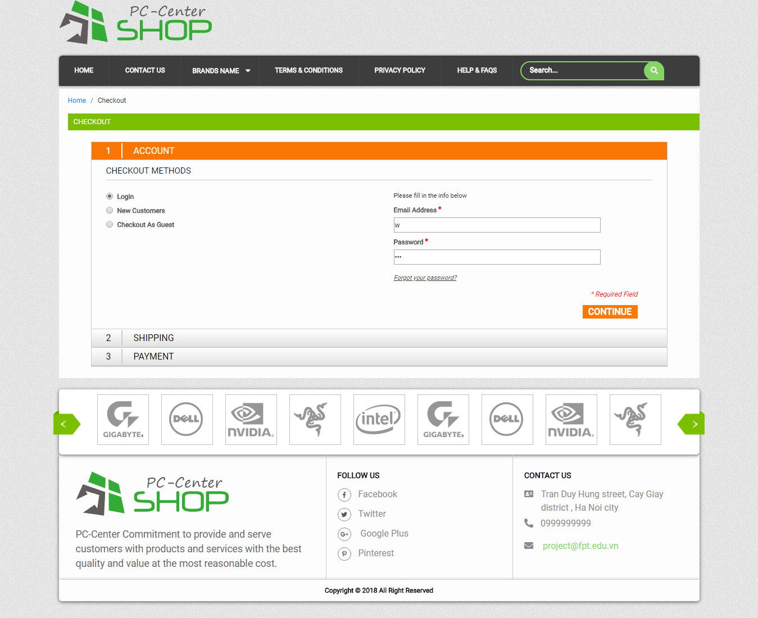

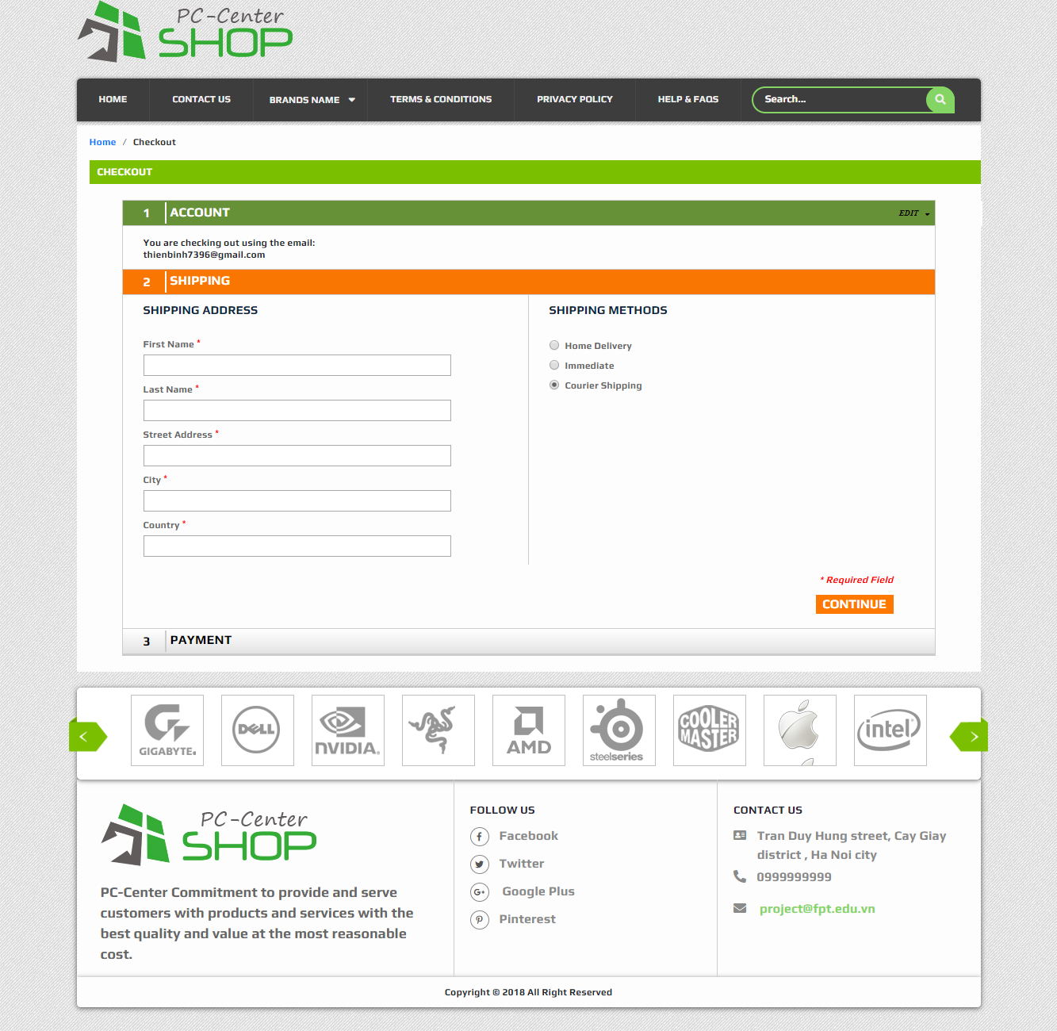

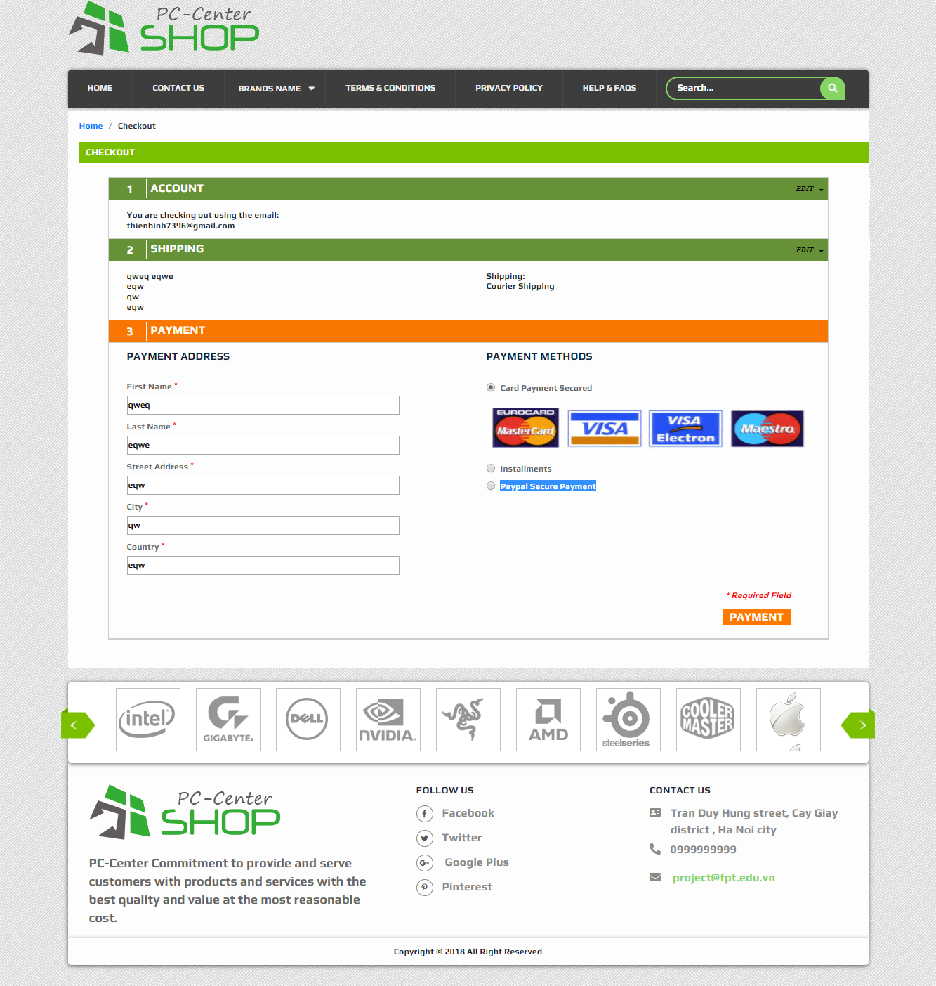

* 1. Help
* This page display detailed information about help and faqs. There are some frequently asked questions.
* Screenshot:

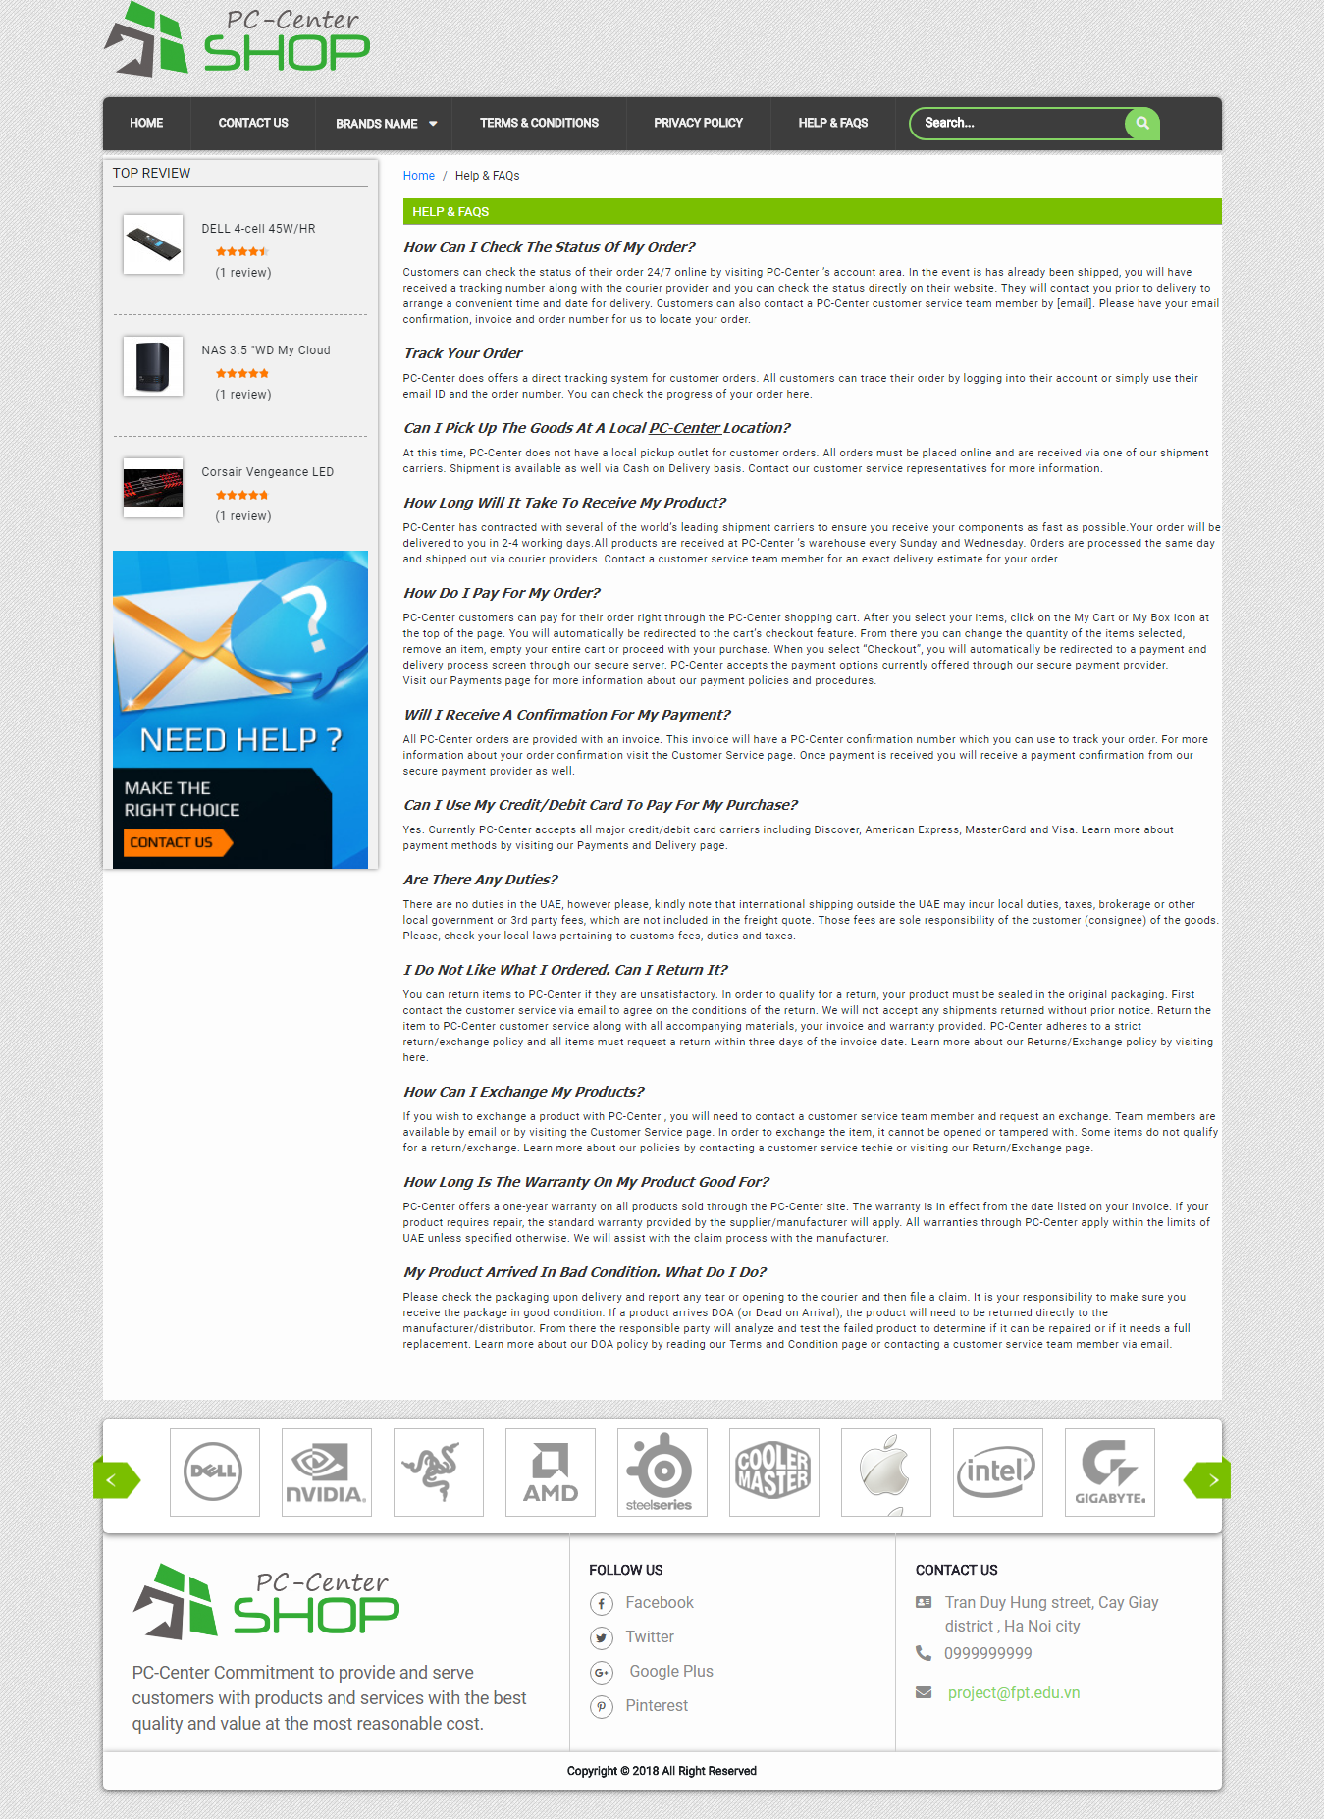

* 1. Privacy
* This page shows the details of the privacy policy.
* Screenshot:

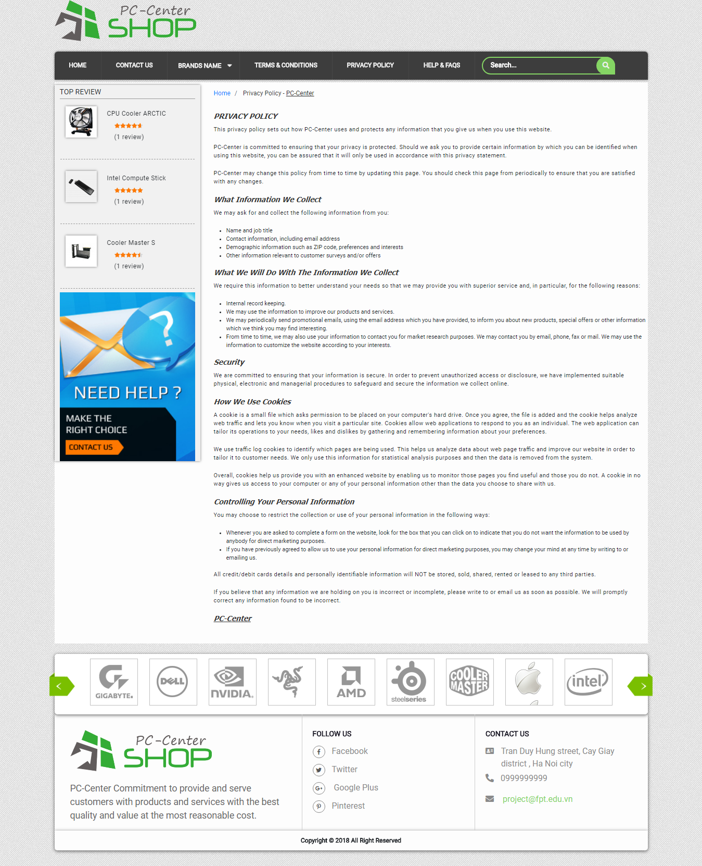

* 1. Term
* This page shows the detailed contents of the terms
* Screenshot:

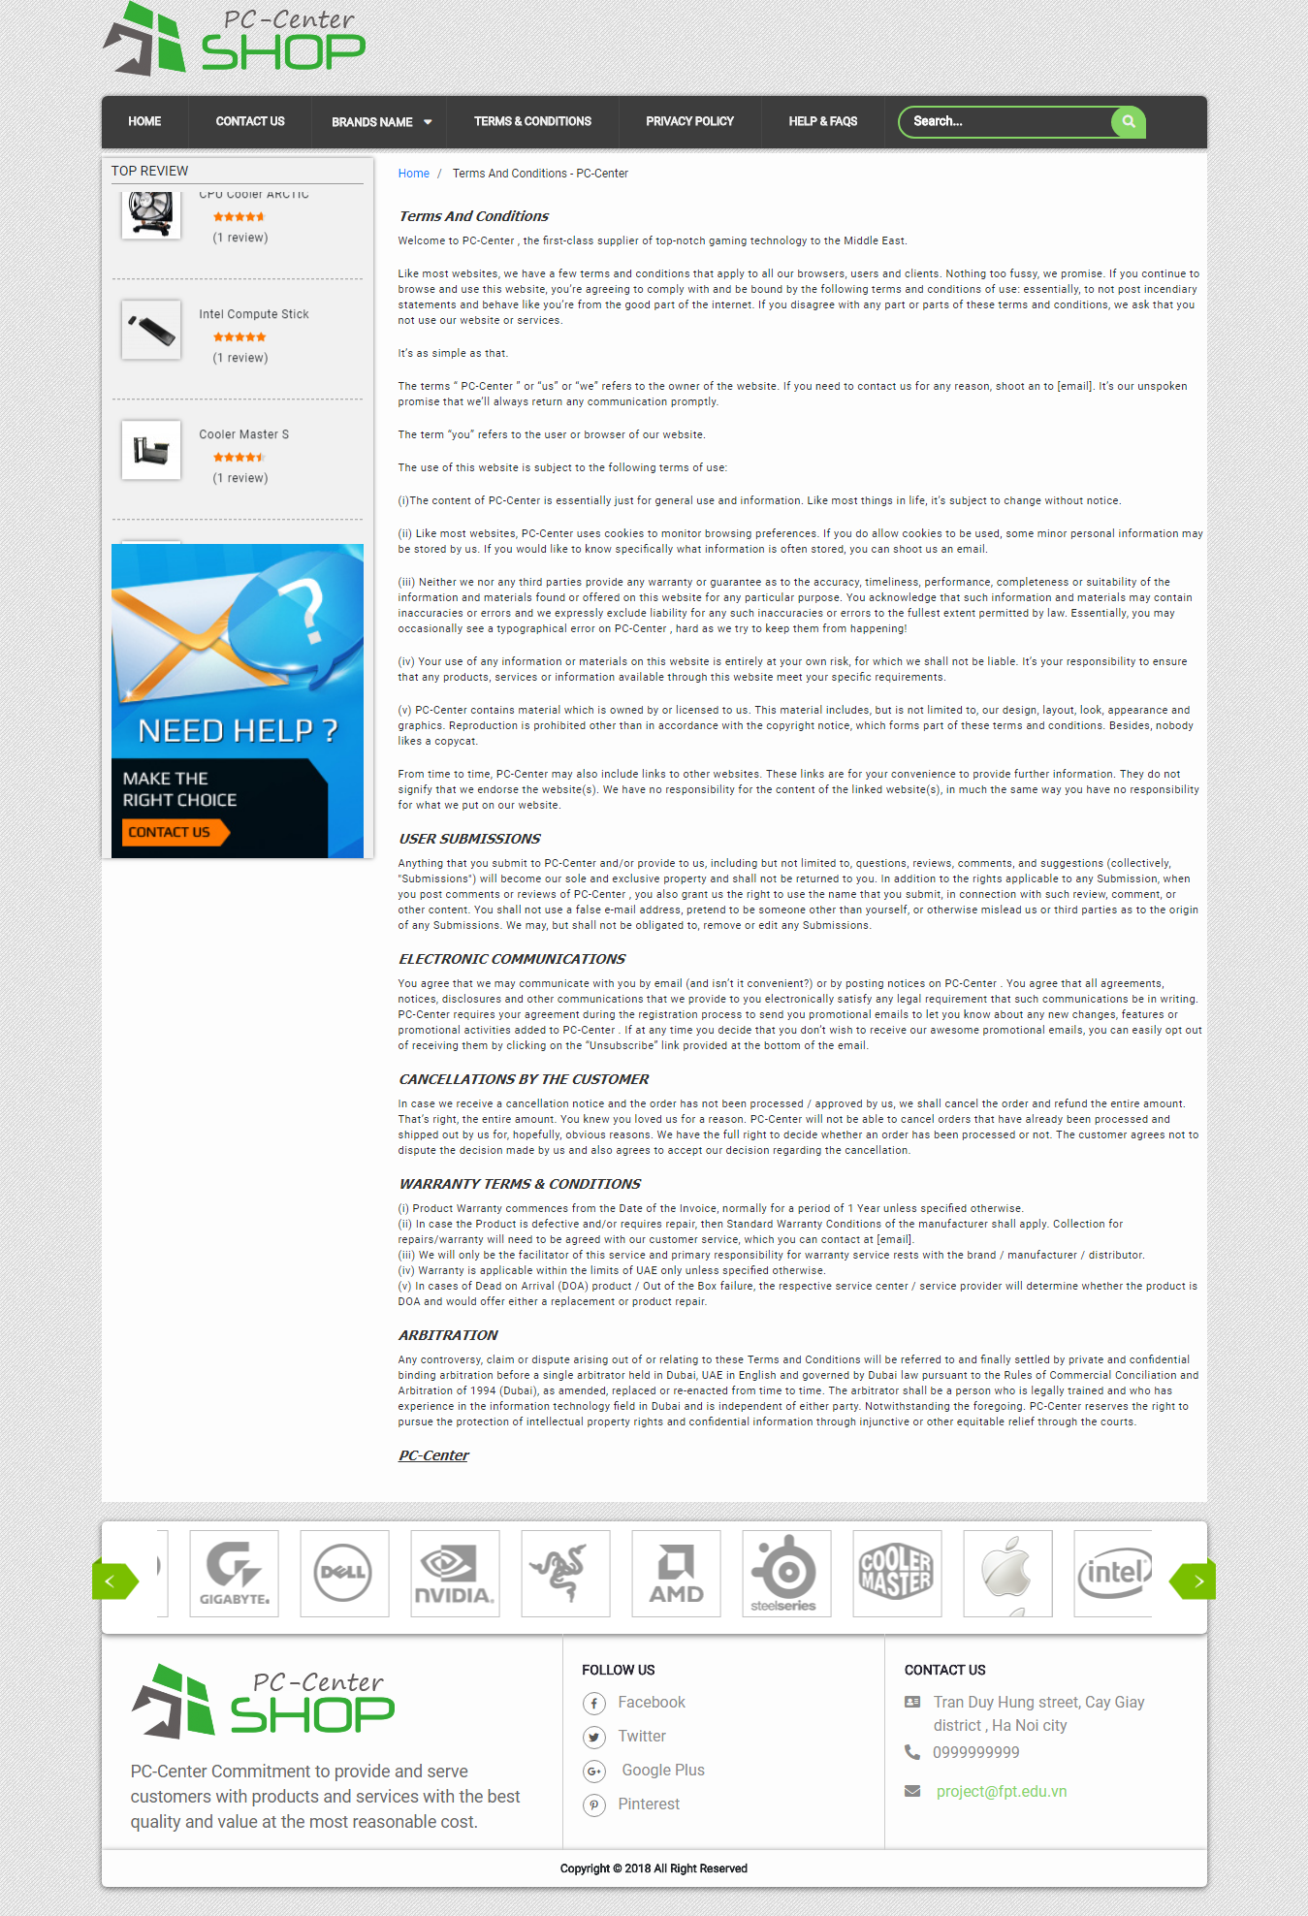

* 1. Contact us
* This page displays fields for users to provide contact information for us such as: Name, Email, Telephone and comment.
* Screenshot:

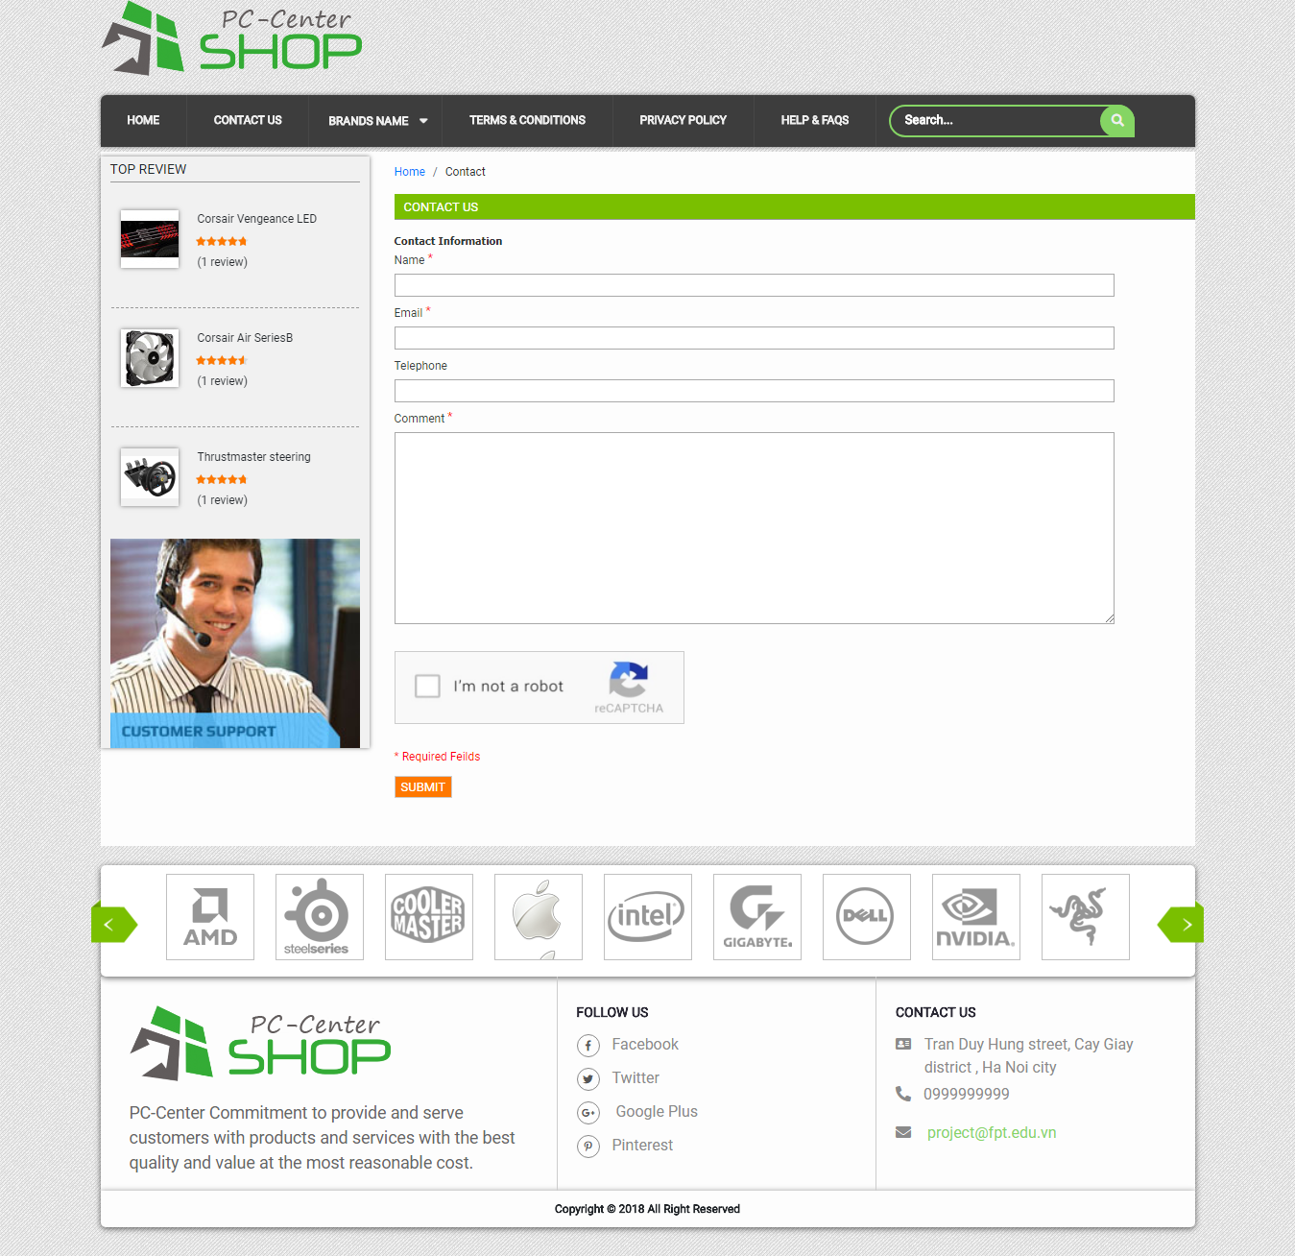

1. **Introduction and Installation**
2. Download the file rar Kimochi Project this link:

<https://drive.google.com/drive/folders/1GhzNEkuiS1VTKuQPByLZdPWK2ntV8QL1?usp=sharing>

1. Extract file rar: Kimochi Project
2. Open folder Kimochi Project

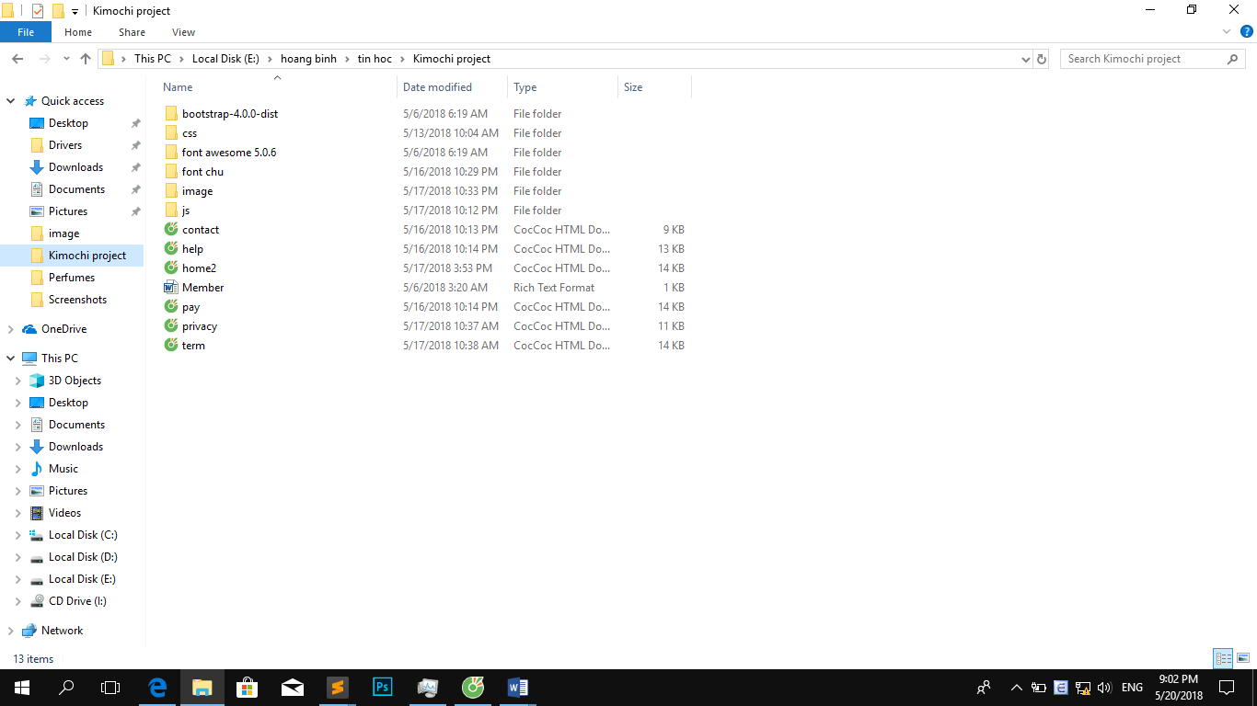

1. Open file home2.html to start website. Look at picture below for illustration

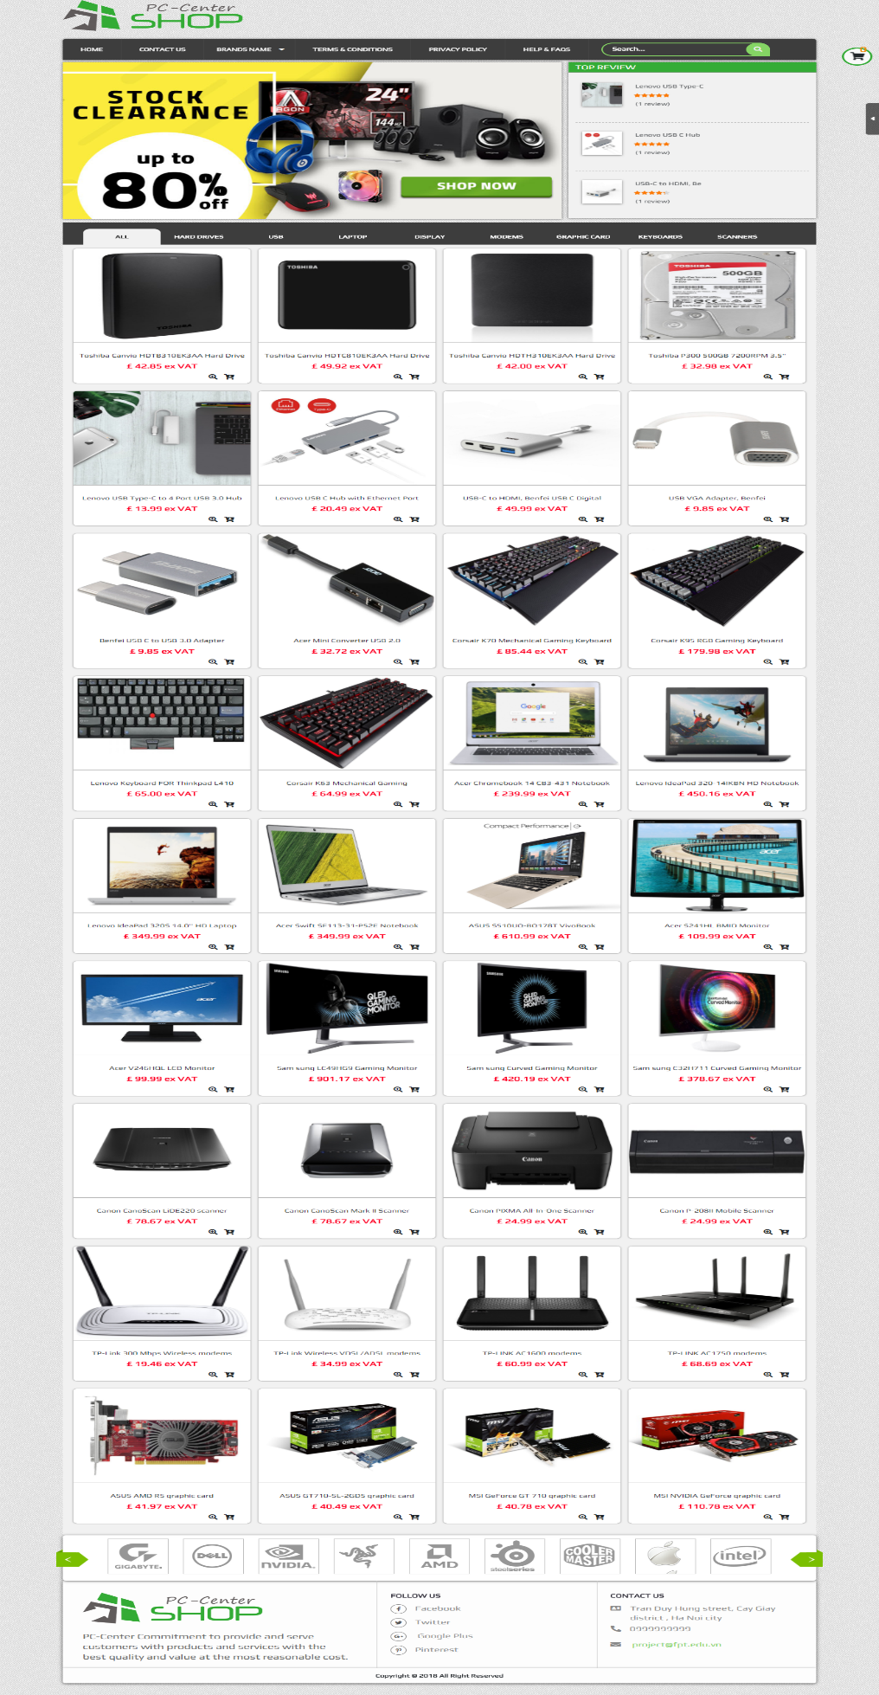

1. Menu :

* This component is the navigation bar for all the webpages in the PC-Center website. To switch to other pages, users simply need to click on a particular section. When you want to view a brand's product, click Brand Name, then select the brand you want to see. The scroll will scroll to product content. For example, picture below illustrates how to switch from Home page to Term and Conditions page.

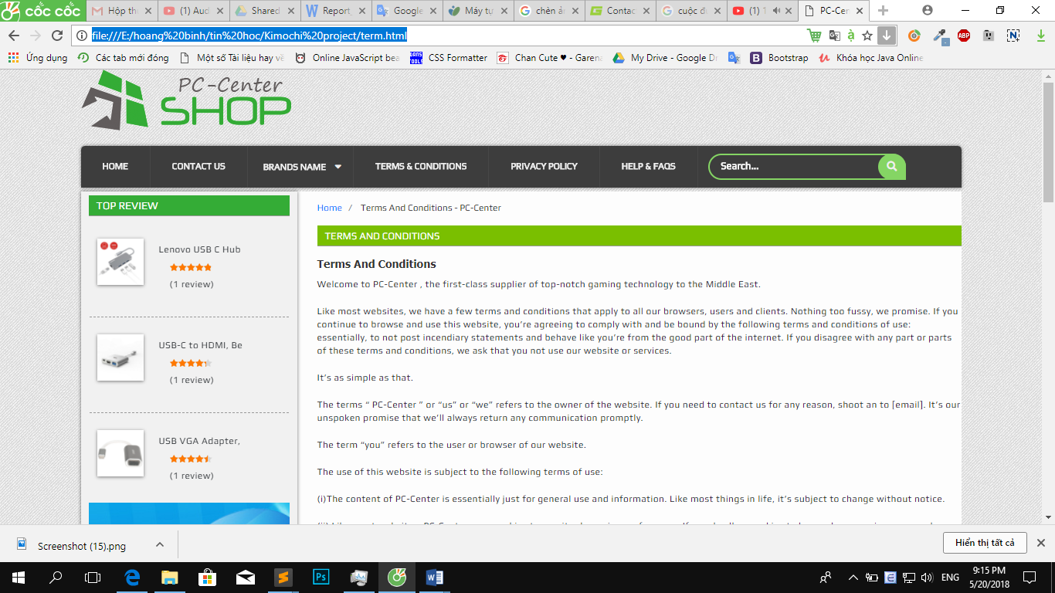

* If you want to search for a product, enter the product name in the search field at the end of navigation bar. Product name suggestions will be displayed. Look at the picture below for illustration.

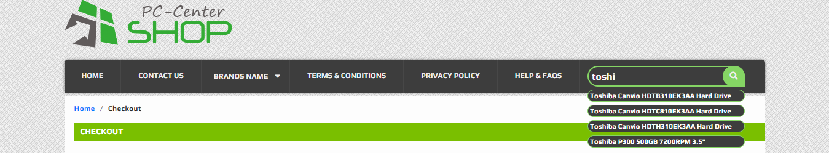

1. Product

* With each product, we have 2 button. The first button show detail information of this product when you click on. The second button add this product to your basket when you click on.

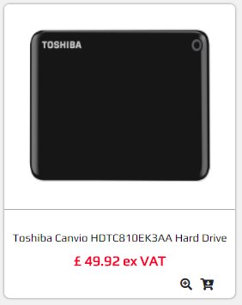

* When you click on a product, the basic product information is displayed. If you want to see detail information of product , click on “more information ” button. The detail information of product will be display include: image galley of product, name, cost, availability and table details information of product. The next picture below show information of “**Lenovo USB Type-C to 4 Port USB 3.0 Hub**”.

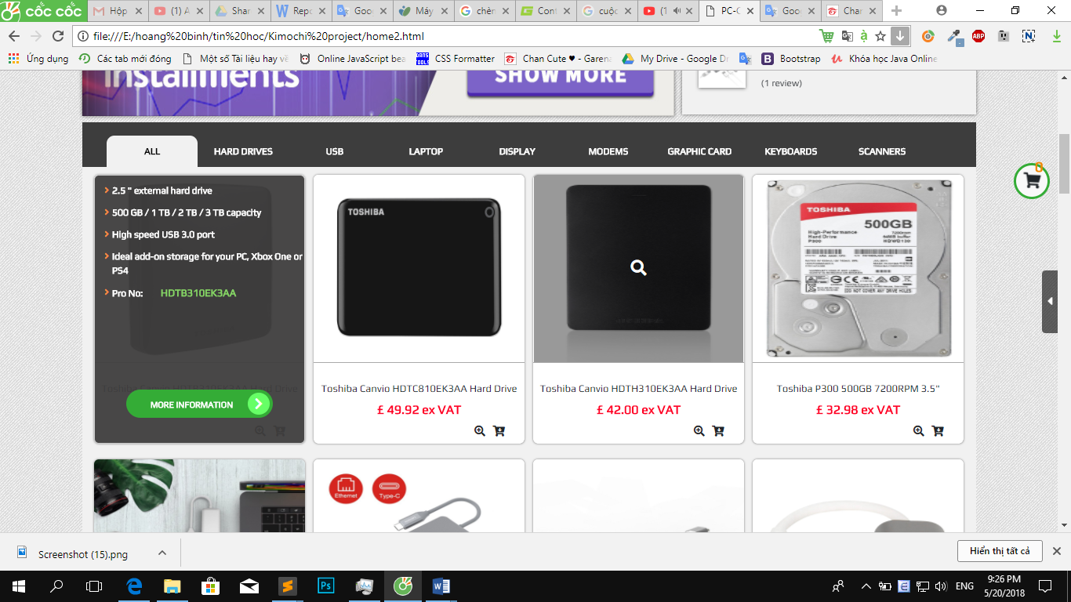

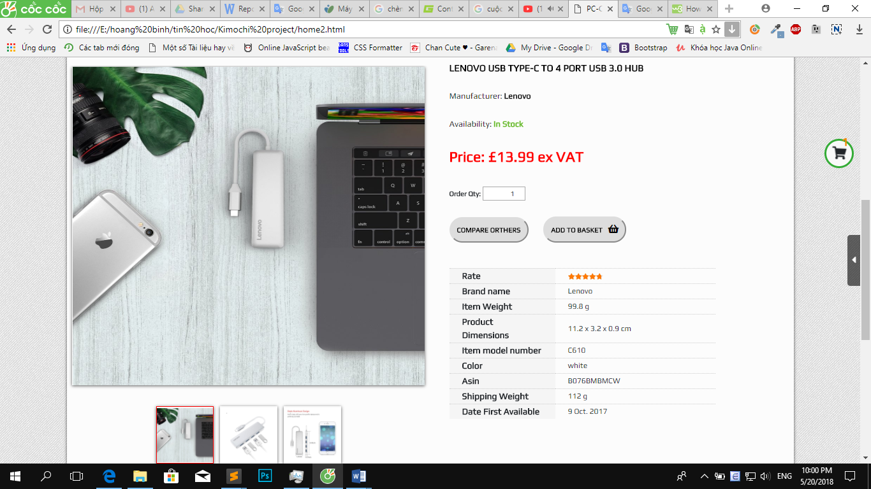

* When you want to compare this product with others product have same type, you click on “Compare others” button. The compare product table will be displayed. The image below shows a comparison of “**Lenovo USB Type-C to 4 Port USB 3.0 Hub**” .

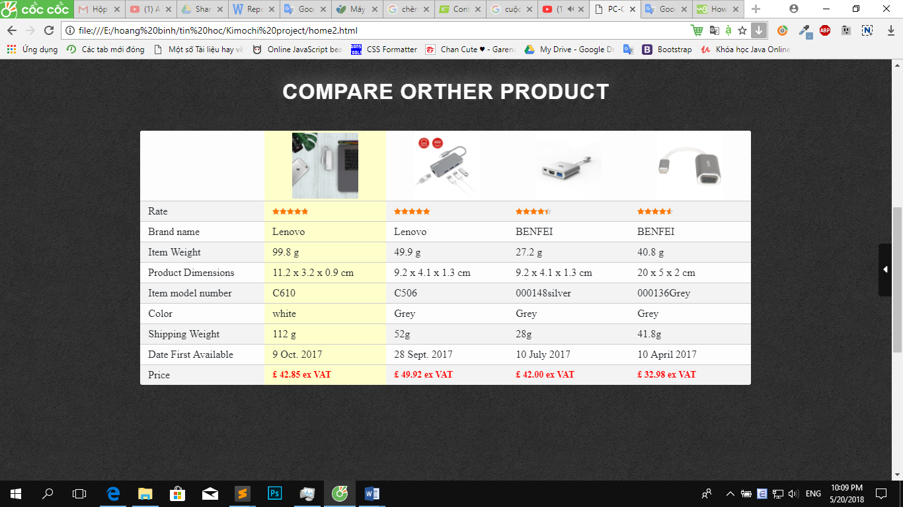

* If your width of browser window > 768px and you want to see enlarge image of the product, please hover image of product and the enlarge image of the product will be displayed. Look at the picture below for illustration.

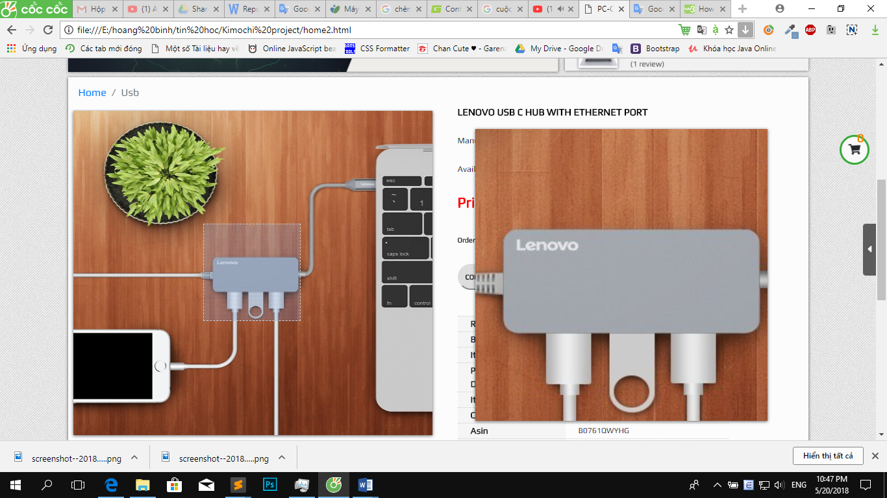

* If your width of browser window < 768px and you want to see enlarge image of the product, please click image of product and the image of the product will be enlarged.

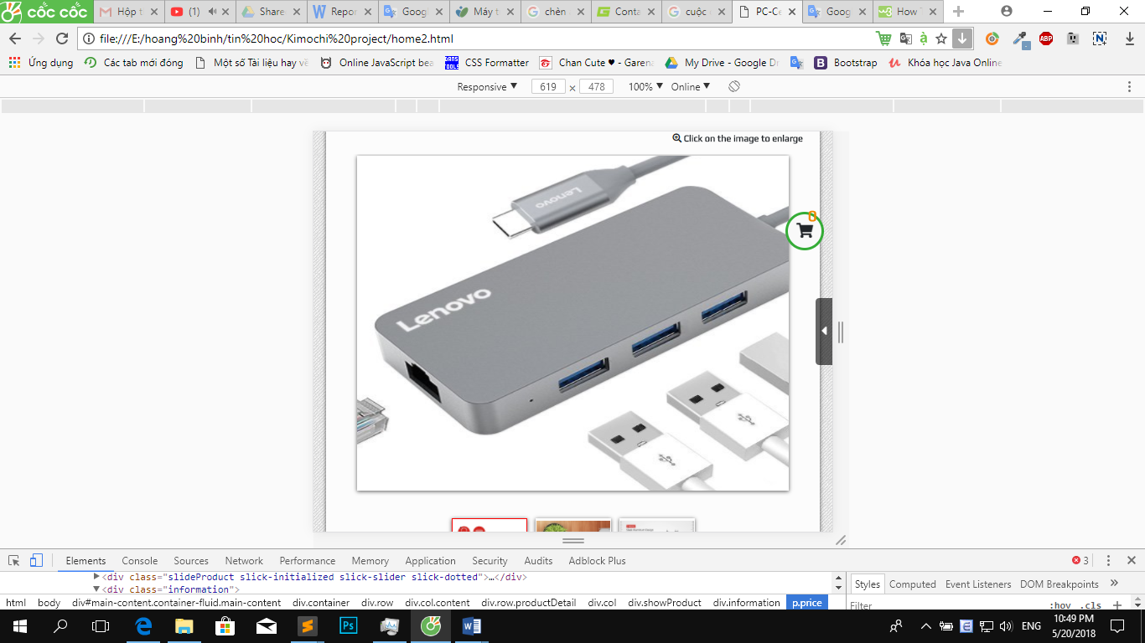

1. Cart

* When you click on “Buy now” button or “Add to basket” button in product, this product will be added to your basket. You can adjust the number of products, when you press on Qty input. You can remove product when you click on remove button next to this product.
* The total amount you pay will be calculated and displayed in total under the basket



1. Payment

* When you click on “Pay” button inside Your Cart, the pay page will be displayed. This page display payment steps to check out your cart.

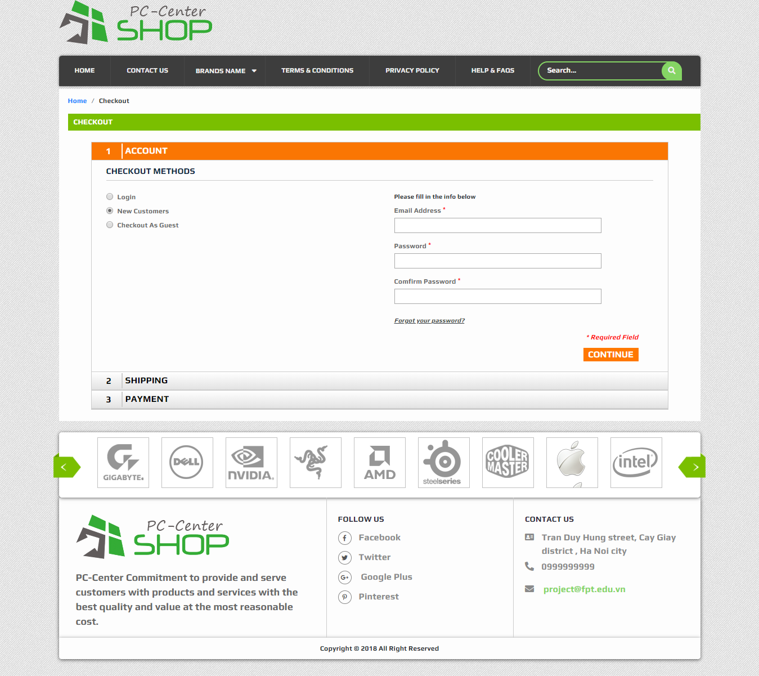

1. **Summary**
2. Implementation Environment

* Language: JavaScript, HTML, CSS
* Framework: Bootstraps, Jquery, Flux.js, Slick.js, Font-awesome, Animate.css
* Software: Slime text 3.

1. Points done and not done:

* Points not done:
  + Website is a static web.
  + Website design is not really beautiful.
  + Some back-end functions are not available yet such as: Payment methods, contact and sign in.
  + Product page load speed is not high.
* Points done:
  + We used javascript, html and css to build many functions such as product filtering, product search, slide show.
  + Most of the functionality on the front end has been completed.
  + The site has solved the requirements set out in the customer requirements specifications.
  + We learned how to work together, assign tasks to each person, the basic steps to do web.